# Portfolio Part 3: Task 3

## Use Profiling Tool

SearchUser Snapshot:

SQL Profiling (SQL)

The SQL profiling tool replays traces of SQL commands sent between the application and the database. In this instance there are two requests to the database. One is that it is requesting all available information be sent to the java application which was invoked once and took 1.39ms to complete. Secondly the application requested that the database supply only those entries where the column of the database FirstName equalled the value ‘Nicholas’.

CPU Sampler

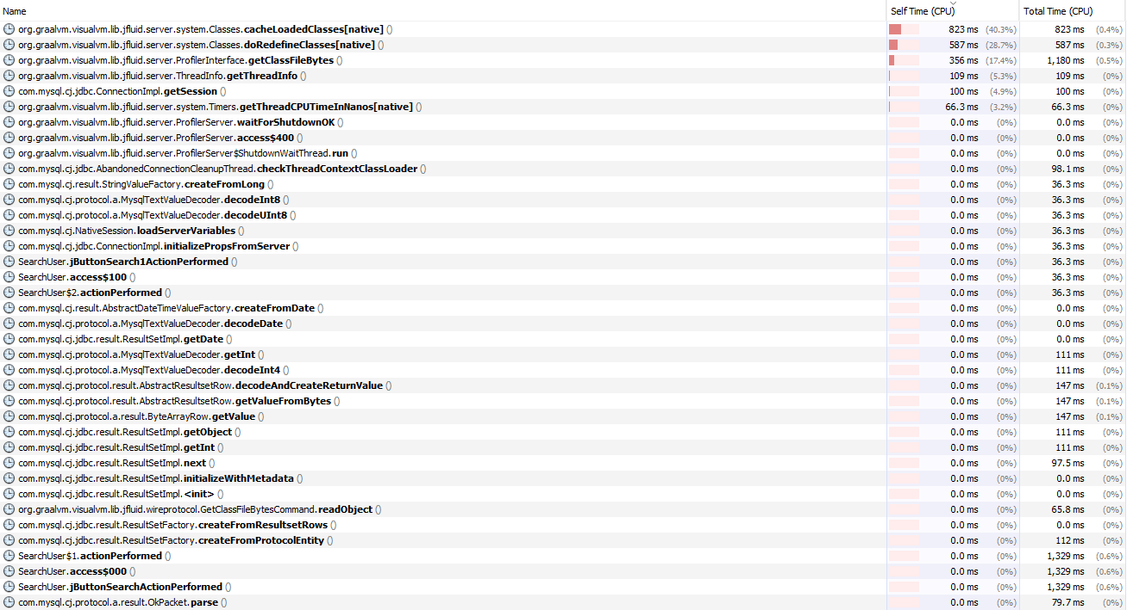

The CPU sampler tool allows for the user to see a snapshot of what is running at a set time. It does this in addition to not noticeably slowing down your program, this allows the user to identify which function in the program are taking to complete, and how long the function is taking of the processors time.

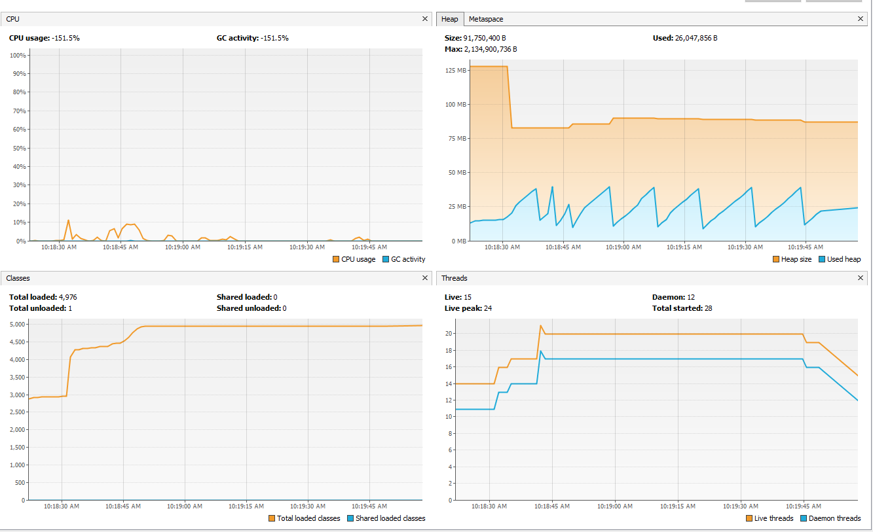General

In this snapshot it includes the activity of the CPU and Memory during the use of UserSearch in the application. CPU usage you will see spikes when activities are occurring within the document, as it takes processing power to complete these tasks, this is reflective in the CPU sampler above. In the memory monitoring there are two categories used: used heap and heap size.

Heap is the area of memory used to store objects instantiated by applications the run on the Java Virtual Machine. Heap size is the maximum space allocated for the application and used heap is how much of that space is actually used throughout the application. As you can see there is a pattern between the CPU and memory charts, increasing when an activity is being done.

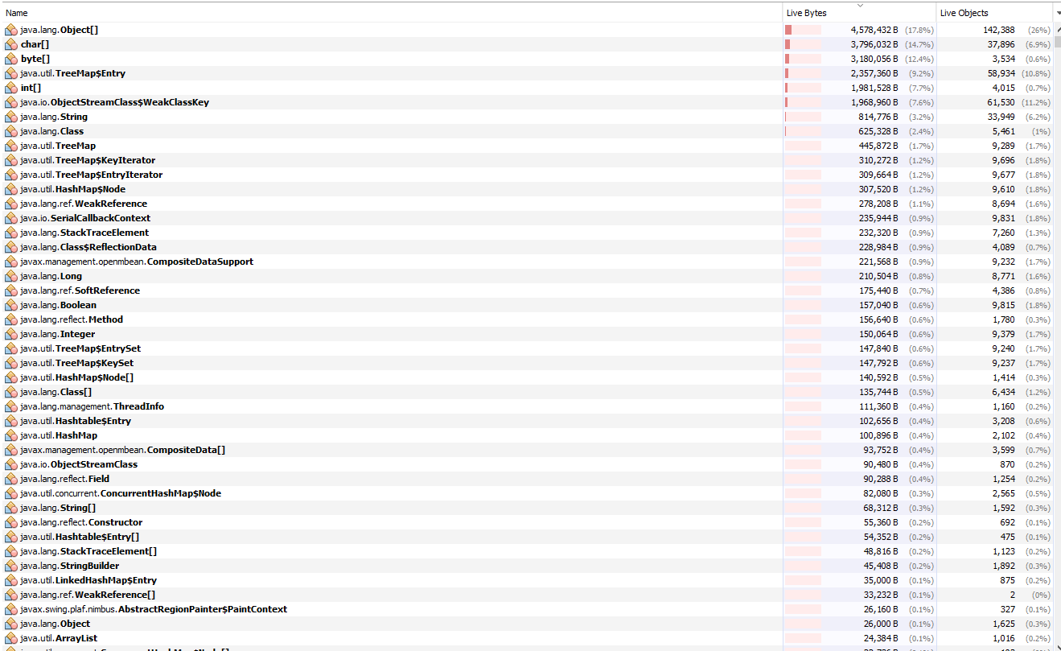Memory Sampler (Methods)

Similarly, to the CPU sampler, the memory handler allows for the identification of which objects or classes are taking up the most memory throughout the application. In this case java.lang.Object[] is taking up the most space. This is important to identify which objects/classes may be slowing down the application.